User Manual

Table of Contents
Table of Contents 2
Quick Start Guide 3
LED Control 3
Modifying the Keymap with VIA 3
Modifying the Keymap with QMK 3
NumM Pad and KMK 3
Recovering from an Unrecoverable State 3
Switch Matrix and Hardware Configuration 4
Main Fuse 4
Switches 4
Encoders 5
Addressable LEDs 5
Built In Current Measurement 6
Onboard memory 6
Reset Switch 6
Test Points 7
ESD Protection 7
Hot Swap Sockets 7
Case and Plate 7
Extra GPIO Pins 7

Quick Start Guide
Install your choice of MX-style switches and keycaps. Cherry profile keycaps are not supported. Next, ensure the reset switch is flipped to on and connect the NumM Pad to your computer using a USB type C cable that is capable of sending data[1]. The LEDs can be configured according to the process below.
[1] Some USB type C cables only send power and no data. An easy way to check which kind you have is to plug a USB type C phone into your computer using the cable and if your computer recognizes the phone the cable is capable of sending data.

LED Control
IDK how rn haha

Modifying the Keymap with VIA
By default, the NumM Pad uses QMK as its firmware, and thus it is possible to edit the keymap and macros using VIA, a graphical software for QMK keyboards.

Modifying the Keymap with QMK
It is also possible to modify the keymap by editing the config files of QMK directly. This can be achieved by unplugging the NumM Pad, flipping the reset switch to ON, and plugging it back in. After plugging it in set the reset switch to OFF. This will enable the USB flashing mode and the NumM Pad will appear as a USB drive on your PC. You can now backup the existing config files, modify them in any way you like, and copy them back to the NumM Pad. Then simply unplug the NumM Pad and plug it back in.

NumM Pad and KMK
Because the NumM Pad is based on the RP2040, which is the microcontroller used in the Raspberry Pi Pico, the NumM Pad firmware is also able to be coded using Micro Python and Circuit Python. Of the two, Circuit Python is recommended because it has a built in USB-HID library to make using the NumM Pad as a USB input device easy. Using Circuit Python, you are also able to read the built in current sensor to see how much current the keyboard is using. This is useful for determining the maximum brightness the LEDs can be set to since the current limit on a USB port is 500mA. To edit the code, unplug the NumM Pad, flip the reset switch to ON, plug in the NumM Pad and flip the reset switch to OFF. This will allow you to easily copy code to the NumM Pad, as well as test it without needing to unplug it again. The library that is being used with Circuit Python is called KMK, and its documentation will give you most of the info you need to code the NumM Pad.

Recovering from an Unrecoverable State
The NumM Pad includes a 3-pin header with 2.54mm pitch pin holes for connecting an SWD flashing device. This will allow you to re-flash the firmware and/or bootloader to the NumM Pad and recover from and unrecoverable state. See the header location and pinout below:

Switch Matrix and Hardware Configuration

Main Fuse
The NumM Pad has a 500mA fuse, that stops current when the current draw is over 500mA, and automatically resets after a period of time. This is designed to protect your computer because standard USB ports can supply up to 500mA. Should the fuse trigger, the board will lose power. In this event it is recommended to let the board cool for 5-10 minutes and turn down/turn off the LEDs. The LEDs can be turned off by changing the switch from on to reset. Fuse Datasheet

Switches
The switch matrix consists of 28 keys, in 7 rows and 4 columns. The layout is slightly confusing in order to minimize GPIO usage. See the diagram below:
GPIO Pin | Row or Column | Keys in the Row or Column
GP16 | Row 1 | Num Lock, Previous Song, Pause/Play, Mode
GP17 | Row 2 | /, *, -, Next Song
GP18 | Row 3 | 7,8,9, +
GP19 | Row 4 | 4,5,6, Delete
GP20 | Row 5 | 1,2,3, Home
GP21 | Row 6 | 0, Up Arrow, Period, End
GP22 | Row 7 | Left Arrow, Down Arrow, Right Arrow, Enter
GP5 | Column 1 | Num Lock, /, 7, 4, 1, 0, Left Arrow
GP4 | Column 2 | Previous Song, *, 8, 5, 2, Up Arrow, Down Arrow
GP3 | Column 3 | Pause/Play, -, 9, 6, 3, Period, Right Arrow
GP2 | Column 4 | Mode, Next Song, +, Delete, Home, End, Enter
The diodes in the matrix go from column to row.
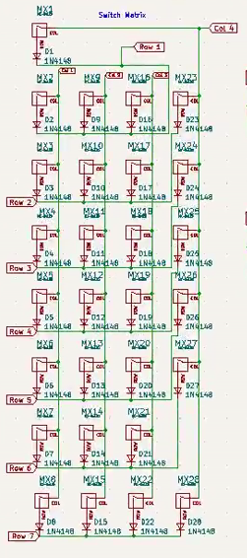

Encoders
Encoders use two pins that each output a signal every 15 degrees of rotation for a total of 24 signals per rotation. The signals from each pin are out of sync, which allows you to know the direction of turning based on which signal comes first. This is called quadrature encoding. See the signal diagram below:
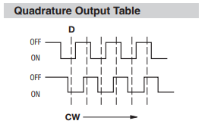
Each encoder uses 3 GPIOs, with 2 for rotary signals and one for the switch that is embedded in the encoders. See the table below:
GPIO | Encoder Pin
GP12 | Encoder 1 Signal A
GP13 | Encoder 1 Signal B
GP11 | Encoder 1 Switch
GP0 | Encoder 2 Signal A
GP1 | Encoder 2 Signal B
GP2 | Encoder 2 Switch
The encoder switch is pressed when the pin is pulled low (logical 0). Encoder Datasheet
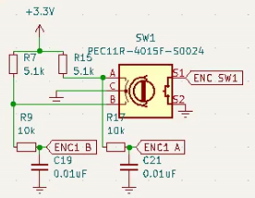
Figure 1 Encoder Schematic

Addressable LEDs
The LEDs used are the SK6812-Mini E LEDs, which can be coded using a variety of libraries. It is recommended to visit the Adafruit website to learn more about these libraries. These LEDs can draw more than 18mA each. With 28 LEDs, that is a maximum of 504mA, which is over the maximum power that a USB port can supply. To prevent the fuse from blowing, the LED’s brightness must be limited to ~75%, with the first LED being 14% brighter than this. The first LED’s supply voltage was stepped down in order to communicate with the microcontroller, but the following LEDs have a standard brightness. The LED control signal is LED DIN, which is on GP22. The LED Enable pin is enabled low, and can be found on GP21. The LEDs are arranged in a snake-like layout, with the LED numbers ranging from 0-27. See the diagram below:
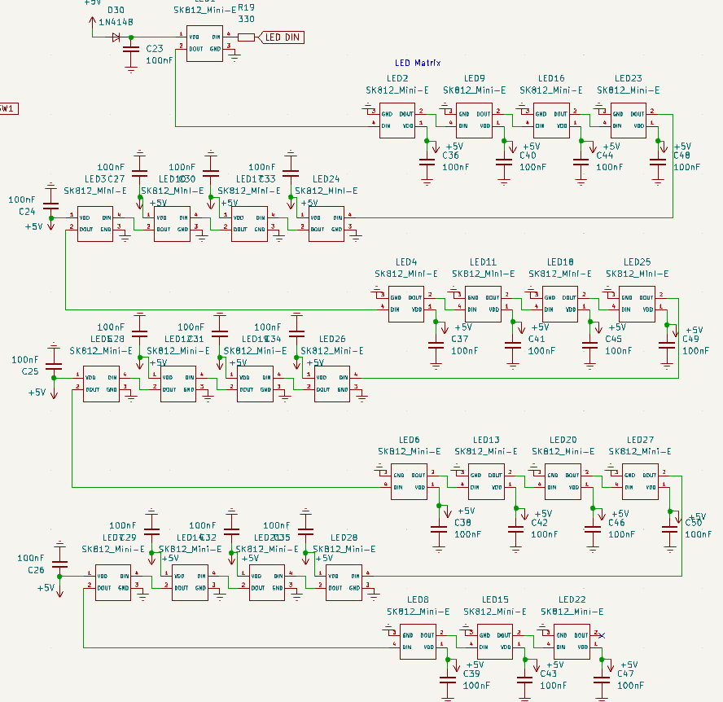
LED Datasheet

Built In Current Measurement
The built in current measurement works using two 1Ω resistors in parallel to provide a 0.5Ω resistance. The resistors each have a 1% tolerance, so the real resistance varies by +/- 0.01Ω. A signal is taken from before (GP27) and after (GP26) the resistors, passed through a voltage divider, and routed to ADC0 and ADC1, which are GPIO 26 and GPIO 27 respectively. The voltage dividers are constructed of 5% tolerance 10kΩ resistors, which will divide the voltage in half since the RP 2040 can only measure up to 3.3V signals. The ADC pins on the RP 2040 have a voltage accuracy of +/- 0.03V, which should be kept in mind. The formula to find the current based on the above two voltage measurements is as follows:

Where V1 is ADC0 x 2, V2 is ADC1 x 2, and Rmeasured is the measured resistance across both 1Ω resistors (approximately 0.5Ω).

Onboard memory
The memory interfaces with the RP 2040 using the chip’s QSPI interface, which is the same way the Raspberry Pi Pico interfaces with its memory. The major difference between these two boards is that the NumM Pad has 4mB of onboard memory instead of 2mB, which will allow you to bring some files with you on the NumM Pad. This is intended to allow you to save an autohotkey script as an exe to allow you to use powerful macros on any windows computer without installing any software on them. Memory Datasheet

Reset Switch
The reset switch has two positions, On and Reset. In the On position the switch will bring LED Enable low, which will allow the LEDs to output. When the switch is in the Reset position, the Reset signal will be grounded, allowing the NumM Pad to be detected as a USB drive and have its code changed. The Reset signal only needs to be low when the NumM Pad is being plugged in; the switch can be moved back to On after the NumM Pad is plugged in. Additionally, the LED Enable signal will be brought high when the switch is in the Reset position which allows the user to turn the LEDs off in the event they caused an overcurrent and the fuse was tripped. LED Enable is GP21.
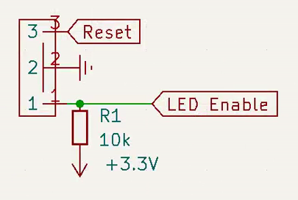
Figure 2 Reset Switch Schematic

Test Points
There are 3 test points on the MCU board, a 3.3V, 5V, and Ground test point. These allow the user to check the supply voltages while troubleshooting using a multimeter or oscilloscope. DO NOT SHORT ANY OF THESE POINTS TO EACHOTHER OR ANY OTHER POINTS. The MCU board also has a reset test point, which can be shorted only to 3.3V and will cause the MCU to reset. The test points are in the following locations:

ESD Protection
The NumM Pad has very robust ESD protection, including a USB isolator on the data lines, an isolator on the power input, ESD suppression ferrites on the USB connector housing and a grounding connector for the case. The case only needs to be grounded if it is conductive. A conductive case can be grounded by connecting a wire from it to the shield connector.

Hot Swap Sockets
The hot swap sockets used are provided by Kailh or Durock and are compatible with all MX-Style switches. The NumM Pad uses a north-facing LED layout to ensure the best keycap shine through, and due to this Cherry profile keycaps are incompatible with the NumM Pad. Special orders with south-facing LEDs may be made.

Case and Plate
The case, plate, and knobs for the NumM Pad are 3D printed with a resin printer. The .stl files for these parts are available on the Git Page along with the rest of the project documentation. This will allow the user to print their own case, or have a case machined from wood or aluminum. Note that 3D printed or wood cases will likely require threaded inserts and the 3D models will need to be modified. The main PCB is 80mm x 177mm, the holes are 3mm in diameter and the center of the holes is 6mm from each edge.

Extra GPIO Pins
The NumM Pad has 2 ADC (Analog to Digital Converter) pins that are extra, along with XX extra standard GPIO pins. These can be connected to using the through hole pads on the MCU daughter board, which have a pitch of 1.2mm. Note that ADC pins cannot be used with the QMK library and thus must be coded separately. ADC pins are fully supported by KMK, so if you are planning to use the ADC pins KMK is recommended. See extra GPIO pins below:
GPIO Function | GPIO Numbers
ADC | GP28, GP29
Normal | GP3, GP8, GP9, GP10, GP11, GP12, GP13

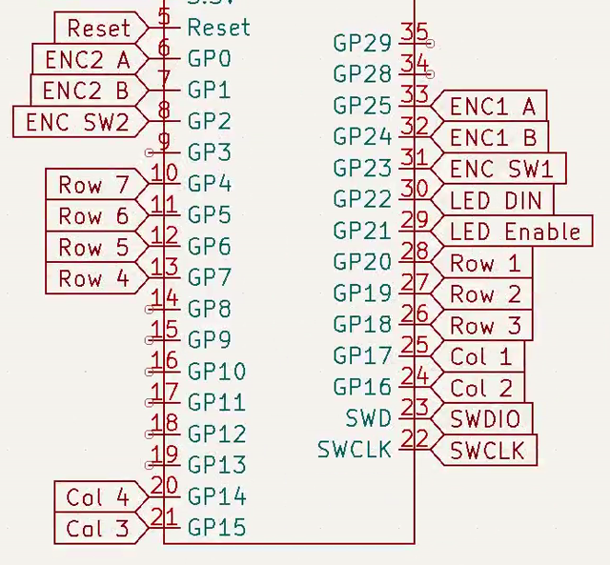
Figure 3 MCU GPIO Pins

